WEST LONDON WASTE AUTHORITY
Report of the Treasurer | 24 June 2022
Draft Finance Strategy

SUMMARY
This report provides a draft of the Authority’s Finance Strategy and the progress from consultation with borough Directors. The key points are:
- The draft has been developed with all six boroughs’ Finance and Environment Directors in collaboration with the Authority’s Officers
- There will be significant change and financial consequences in coming years arising from legislation as detailed in section 1 of the strategy
- There is a need to find a mechanism to fund that change as detailed in section 3 of the strategy.
- There is a trade-off between the amount of new income disbursed directly to boroughs and the level of uncertainty around levies as detailed in section 4 of the strategy.
- A proposed balance essentially sharing the new income on the basis of two thirds being passed through to boroughs directly and one third being retained by the Authority for delivery of strategic plans. For 2021/22 two thirds of new income totals £6.5 million and will be paid to boroughs. One third (£3.2 million) will be retained by the Authority.
RECOMMENDATION(S)
The Authority is asked to: -
- Approve for consultation with borough Directors, the Draft Finance Strategy found in Appendix 1
- Note the aim to bring a final document to the September Authority meeting for approval
- Introduction
The draft Finance Strategy brings together the established mechanisms which have built solid financial foundations together with recent changes such as new income from rising electricity prices.
It supports the delivery of the developing joint WLWLA strategy.
The first draft of the Finance Strategy was shared and discussed at meetings with borough Finance Directors and Environment Directors. Their feedback identified some changes and also the need for further data to make a more informed decision.
The Finance Strategy has been updated to reflect these changes and work is underway gathering the additional data. The aim is to share and work with borough Directors to agree a strategy for recommendation to the September Authority meeting.
- Key Elements of Borough Directors’ feedback
Below are key elements of feedback from Finance Directors and Environment Directors on the first draft together with responses:
- Further data and information was requested. These are identified in Appendix 2 and will be collated and shared with borough Directors in coming months as part of the strategy development work.
- Clarification of the timeline for approval of the Finance Strategy – the development of the Finance Strategy is an iterative process including further consultation with Finance Directors and Environment Directors during the summer and aiming for approval at the September Authority meeting
The timeline includes:
  - Producing and sharing the additional information requested (by the end of June)
  - Meetings with borough Directors to collectively consider the additional information, receiving feedback and making appropriate changes (by the end of July)
  - Sharing the updated final version of Finance Strategy (2nd week of August) and requesting formal feedback from Finance Directors (similarly to the budget setting process)
  - Deadline for formal feedback (1st week of September)
  - Recommendation of the final version of Finance Strategy to the Authority (23 September)
- Clarification that £1 million (i.e. 2/3rd of the new income) will be disbursed to each of the boroughs and will be for boroughs to determine the use – the Finance Strategy has been amended accordingly.
- Details to be provided regarding the timing of the payment to boroughs – payment will follow the approval of the Finance Strategy i.e. aiming for approval at the September Authority meeting and payment in October.
- The level of reserves were considered to be excessive in comparison to reserves held by some boroughs – the existing approach has been clarified in the Finance Strategy and is considered appropriate. This explains the mechanisms and transparent approach for setting a target level for reserves and disbursing excess reserves to boroughs. These follow annual cycles and every year a recommendation is made when the draft financial statements are reported, typically at the June Authority meeting. This year’s recommendation can be found in today’s Authority agenda in the draft accounts report. A total £3.2 million disbursement has been recommended, to be allocated to boroughs on the basis of the Council Tax bandings as detailed in that report.
- Managing the Uncertainties Ahead
The draft Finance Strategy has been developed in context of uncertainties on the near horizon, principally in the form of significant change resulting from legislation. Appendix 3 illustrates the financial impact of this legislation.
The opportunity and emergence of new income enables the Authority to effectively and proactively manage its risk through ring-fencing / setting aside some of that income (through reserves) for waste projects which will deal with the change and minimise the impact on levies.
It is important to highlight that much of the change arising from legislation will impact boroughs directly. There will be significant resulting financial pressures facing borough waste collection activities in delivering this change.
Therefore it is recommended that boroughs also consider ring fencing / setting aside a portion of their share of the new income for borough waste collection activities.
In particular given that much of the new income is one off in nature (from electricity price rises) investing in borough waste projects can mitigate future cost pressures of both having to implement the changes and also of potentially increasing levies.
A balance suggested is one third for Finance Directors for general borough use, one third ring-fenced by boroughs for Environment Directors projects and one third retained by WLWA for its strategic projects.

- Disbursement to boroughs
For clarity, the table below shows the total to be disbursed to boroughs including both the new income generated in 2021/22 and also the excess reserves at the end of 2021/22.
Borough | Approved Council Tax Base | New Income (£000s) | Excess Reserves at end of 2021/22 (£000s) | Total (£000s)
Brent | 99,868 | 1,103 | 553 | 1,656
Ealing | 118,649 | 1,311 | 658 | 1,969
Harrow | 90,597 | 1,001 | 502 | 1,503
Hillingdon | 103,840 | 1,147 | 575 | 1,722
Hounslow | 86,769 | 958 | 481 | 1,439
Richmond | 88,703 | 980 | 492 | 1,472
Total | 588,426 | 6,500 | 3,261 | 9,761
The totals have been apportioned using the council tax base as in previous years.

- Next Steps
To produce the data and information requested and work with borough Directors to consider and finalise the Finance Strategy for approval at the September Authority meeting.

Contact Officers | Jay Patel, Finance Director 01895 54 55 10  jaypatel@westlondonwaste.gov.uk  Ian O’Donnell, Treasurer  ianodonnell@westlondonwaste.gov.uk  Emma Beal, Managing Director  emmabeal@westlondonwaste.gov.uk

Appendix 1
West London Waste Authority Draft Finance Strategy
- Background
The environment that the Authority and Boroughs work in is rapidly changing. Recent and emerging legislation will result in challenges and risks that we will need to manage and things that we will need to do, which won’t be optional.
Net Zero, Climate Emergency, Consistency, Extended Producer Responsibility, Deposit Return Scheme and the Emissions Trading Scheme are some examples of where we already have or will soon see new legislative requirements.
The scale of the change required will be significant and a key question for both the Authority and boroughs is how will we fund that change?
The March 2022 WLWA Strategy Day with borough stakeholders commenced collective work to develop the Authority’s strategy and understand/prepare for the implications of this legislation. This collaborative work will continue and will result in the development of long-term action plans in the coming years working towards a joint vision for 2030.
The Finance Strategy provides a framework for supporting the delivery of those action plans.
- Aims
For several years the Authority’s financial management has delivered:
- A strong financial platform allowing the funding of strategic plans/projects for both the Authority and boroughs
- Effective cost control and containing growth in levies to well below inflation
- Certainty and predictability about costs and levies over the longer term
- Effective management of financial risks through reserves
- Disbursements of any excess balances to boroughs
These are the continuing aims of the Finance Strategy.
- Finance Strategy
The Finance Strategy brings together a number of key long established considerations and processes together with recent developments such as new income and the need to fund developing strategic plans.
- Cost control and stability – this includes the procurement rules which drive good value and sustainable purchasing. It also includes the budget setting process (in particular the scrutiny from a variety of stakeholders providing suitable challenge) which provides a focus on costs and levies. To give certainty to all stakeholders, each years overall variance from the balanced budget will be absorbed through reserves, meaning no in-year levies in the event of an overspend.
- Financial planning for stability – long term financial plans, modelling and sensitivity analysis identify and provide an understanding of the business’s key strategic financial drivers, opportunities and risks through their impact on costs and levies. This also facilitates effective cash and debt management and ensures planning for suitable levels of liquidity throughout the term. Long term plans will be reviewed at least annually and also on emergence of any significant projects.
- Risk and reserves – key financial risks are managed through reserves (less artificial revaluation gains). Essentially an amount is set aside to deal with the risks should they materialise. This is reviewed annually as part of the budget setting process to determine a suitable level of reserves to maintain. Reserves are gradually built up when necessary through accumulation of surpluses arising during years when overall levies exceed overall costs.
- Disbursement of excess reserves – when the level of reserves (other than artificial revaluation gains) materially exceeds the sum needed by the Authority to manage risks (as budgeted), the excess is apportioned using the council tax base and disbursed to boroughs. This is reviewed annually on production of the draft financial statements. Additional disbursements have been made possible by deploying Authority reserves to fund borough improvements that are aligned to the Authority’s strategic plans – e.g. food waste.
- Business cases – any significant project requires a business case to demonstrate that the return (financial or other) for either the Authority or boroughs is commensurate to the investment. Importantly, business cases can consider benefits from a holistic west London perspective which means boroughs can benefit directly rather than the project being of benefit to the Authority, provided they are aligned to the Authority’s objectives. The business case will be approved by the appropriate decision making body per the delegated authority.
- Funding – the options for funding strategic plans/projects, principally includes the use of new income set aside in reserves or borrowing financed through future levies. To minimise the impact on levies, using reserves is the preferred option. This is explained in more detail in section 4. Reserves will have to be built up accordingly, through new income.
- New income – the PPP contract has provided the opportunity for generating new income. There will be income over the short term, significantly relating to 2021/22 with a likelihood of some relating to 2022/23. Over the short term this is largely from increased electricity prices. Over the longer term there may also be opportunities to secure income by increasing third party waste volumes processed at the SERC. Two thirds will be passed on to boroughs directly and one third will be retained by the Authority to fund strategic plans/projects.
- Reserves – this will comprise of reserves built up to manage risks (as identified earlier) and new income set aside (less any subsequently used) to fund Authority strategic plans/projects. Anything in excess will be disbursed to boroughs as identified earlier. Suitable liquidity will be maintained to ensure funds are readily available for these purposes. Reserves set aside for strategic plans/projects will also be reviewed annually as part of the budget setting process to ensure levels are suitable and not excessive, with disbursement being made accordingly.
- The Trade-off
The use of new income for funding can be considered as a scale with two options at polar opposite ends of that scale and many choices in between. The scale essentially represents a trade-off between
- The level of certainty/predictability about growth in levies and
- The amount of new income disbursed directly to boroughs
The more of new income that is disbursed to boroughs the more volatile and bigger will be the movement in levies, as illustrated over the page:
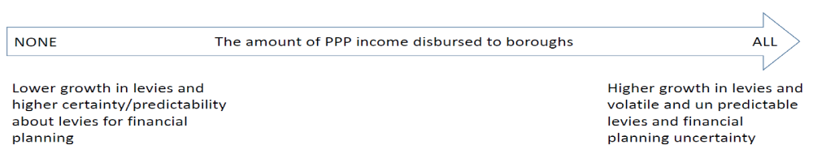
To explain the illustration in a little more detail:
At one end of the scale, all new income can be retained by the Authority to fund the strategic plans. This option will provide greater certainty/predictability about levies over the longer term and contain growth to well below inflation. This is because the option reduces the need to borrow and finance that borrowing through increased levies. Furthermore, it allows the benefits (financial, carbon etc.) to be seen by boroughs in subsequent years in accordance with the business cases. The disadvantage of this approach is that there is no disbursement new income to boroughs.
At the other end of the scale, all new income can be disbursed directly to boroughs. The disadvantage of this approach is that the levies will become less predictable and more volatile. The levies will depend on the timing of projects and the borrowing to fund strategic plans. This will create uncertainty for both the Authority and boroughs and financial planning will become more challenging in order to deal with the movement in levies year on year.
This reflects a typical short term benefit vs long term stability, financial planning trade-off.
- The Balance proposed
There are two other factors worth considering in context of arriving at a suitable trade off, the scale of the new income and the financial challenges facing boroughs.

So, on the basis that the scale of new income is far more than anticipated as are the financial challenges facing boroughs, the strategy leans towards the majority (two thirds) of new income being passed through to boroughs directly. One third will be retained by the Authority for delivery of strategic plans.

However boroughs will need to be mindful of the risk of a rise in levies in the future if funding, beyond that retained by the Authority from new income, for projects becomes required.
- Key Financials
The Finance Strategy provides a mechanism for delivering better financial certainty in uncertain times as described by the aims.

It also strikes a balance between different stakeholder needs and also supports the delivery of the wider strategy for the Authority currently being jointly developed.
These are illustrated in the following tables which provide a projection of key financials from the Finance Strategy.

- New income
 | 2021/22 | 2022/23 | 2023/24 | 2024/25 | 2025/26
One off from electricity | 8,691 | 6,000 | 0 | 0 | 0
Recurring | 1,059 | 1,500 | 1,500 | 1,500 | 1,500
Total new income | 9,750 | 7,500 | 1,500 | 1,500 | 1,500
The 2021/22 figures are from the draft out-turn position for the year.
Caution – the estimates for 2022/23 onwards are notional and dependent on market electricity prices and success with securing recurring new income. Stakeholders are advised not to use the notional estimates above in financial planning.

- Pass through to boroughs
 | 2021/22 | 2022/23 | 2023/24 | 2024/25 | 2025/26
2/3rd of one off | 5,794 | 4,000 | 0 | 0 | 0
2/3rd of recurring | 706 | 1,000 | 1,000 | 1,000 | 1,000
Total | 6,500 | 5,000 | 1,000 | 1,000 | 1,000
These will apportioned and paid to boroughs in October.

- Reserves for Authority strategic plans
 | 2021/22 | 2022/23 | 2023/24 | 2024/25 | 2025/26
Brought forward | 0 | 3,250 | 5,750 | 6,250 | 6,750
1/3rd of one off | 2,897 | 2,000 | 0 | 0 | 0
1/3rd of recurring | 353 | 500 | 500 | 500 | 500
Total | 3,250 | 5,750 | 6,250 | 6,750 | 7,250
These sums will be retained in reserves and used to fund Authority strategic plans. The balances will reduce as reserves are spent.

- Reserves to manage risks (i.e. excluding revaluation gains)
 | 2021/22 | 2022/23 | 2023/24 | 2024/25 | 2025/26
Brought forward | 7,818 | 9,200 | 9,200 | 9,200 | 9,200
Surplus/(deficit) | 722 | 0 | 0 | 0 | 0
Pension liability movement | 3,921 | 0 | 0 | 0 | 0
Total | 12,461 | 9,200 | 9,200 | 9,200 | 9,200
Reserves target | 9,200 | 9,200 | 9,200 | 9,200 | 9,200
Excess reserves paid to boroughs | 3,261 | 0 | 0 | 0 | 0
The reserves target will be set annually as part of the annual budget setting exercise and will be based on risks at the time. It is unlikely they will remain at £9.2 million.
Excess reserves result from day to day operations and will be apportioned and paid using the council tax base.
- Forecast levies
The long term financial plan has been updated to:
- use a long term assumption for inflation of 4% per year (2% was used when setting the budget).
- include the new income netted off against levies
The impact on levies is illustrated in the table below.
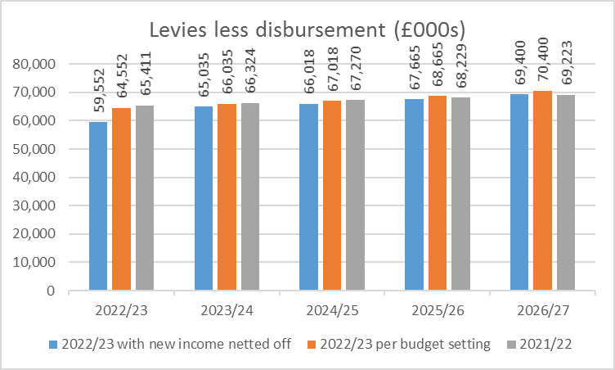
This shows a continuing healthy financial position compared to the projections from 2021/22 and during the 2022/23 budget setting. The forecast is particularly better over the next year due to one off income (subject to significant uncertainty) and subsequently with recurring income largely offsetting the impact of the increased inflation assumption.

Appendix 2

The information below has been requested to inform the further development of the Finance Strategy together with borough Directors.

- A pack identifying change and risks on the horizon – this is to help make better informed decisions about the “disburse vs levy risk trade-off”. Potentially this could be by material stream.
- A financial model of PPP electricity income scenarios to help inform choices around different levels of disbursement depending on how much is received.
- A model showing what levies will look like if we kept all reserves, no reserves, something in between.
- Governance arrangements if borough funds were retained within the Authority
Appendix 3


